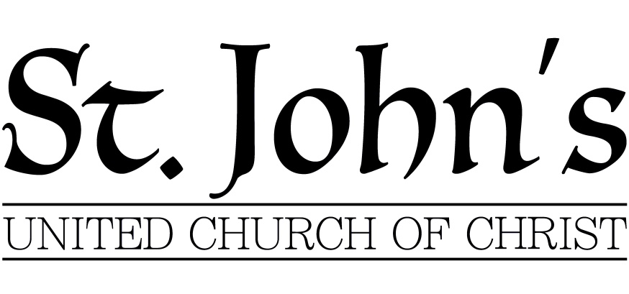
Welcome, Woodland Presbyterian Church
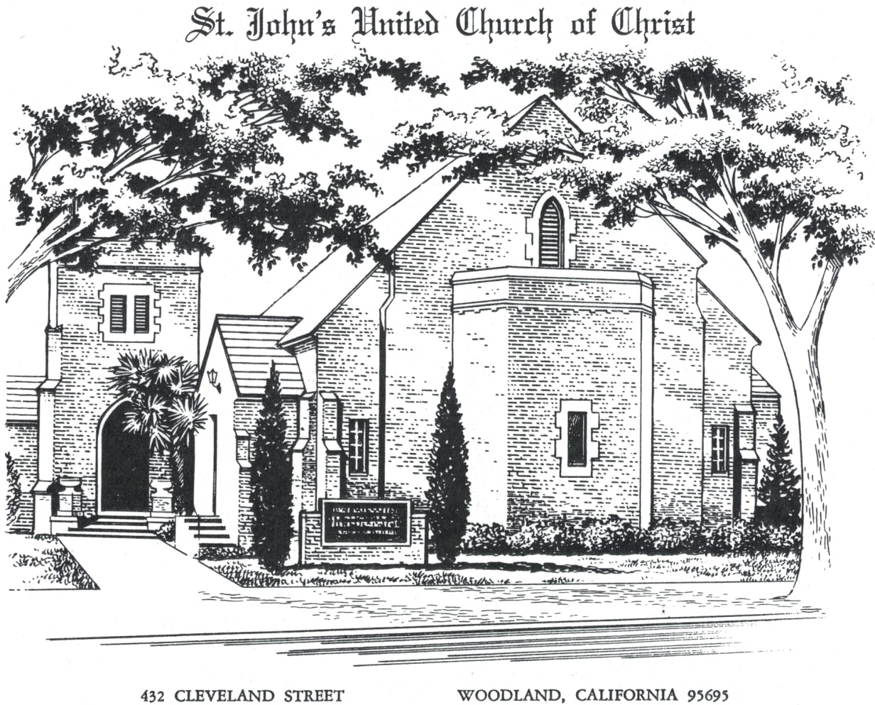
Dogma:
What Christians Believe, And Why We Believe It
Knowing God
July 25th, 2017
✙
(530) 662-5921
www.stjohnswoodland.net
Rev. Will Norman, Minister, St. John’s United Church of Christ
Rev. Christin Norman, Minister, Woodland Presbyterian Church
Service for the Lord’s Day
* indicates that the congregation rise in body or in spirit
GATHERING
Prelude
A time for prayer & meditation, and/or greeting our fellow worshipers.
Please silence cell phones, and be respectful of those around you.
At 10am we will stand to sing Part of the Family (inside cover of Hymnal)
Welcome and Announcements
* Call To Worship (Adapted from Genesis 35)
One: Go up to the house of God and settle there.
Build an altar to God, who appeared to you.
All: We turn over our idols to worship the one true God
One: Come, let us go up to the house of God,
who answers our distress
who has been with us wherever we have gone.
All: We bury our idols in the dirt,
and worship the one true God,
who is forever praised. Amen.
* Hymn #670 O Word Of God Incarnate

1 O Word of God incarnate,
O Wisdom from on high,
O Truth unchanged, unchanging,
O Light of our dark sky:
we praise you for the radiance
that from the hallowed page,
a lantern to our footsteps,
shines on from age to age.
2 The Church from her dear Master,
received the gift divine,
and still that light is lifted
on all the earth to shine.
It is the chart and compass
that, all life's voyage through,
'mid mists and rocks and quicksands,
still guides, O Christ, to you.
3 O make your Church, dear Savior,
a lamp of purest gold,
to bear before the nations
your true light as of old;
teach us, your wandering pilgrims,
by this our path to trace,
till, clouds and darkness ended,
we see you face to face!

* Call To Confession
* Prayer of Confession (unison)
God of Good News,
In Jesus Christ you reveal Your true righteousness
as well as Your wrath against untruth and injustice.
Yet in spite of what you have shown to be true
we look elsewhere for the assurance
that can only come from God.
We fix our eyes upon the rich and powerful,
putting faith in their secrets to a fulfilling life
while You lift up the poor and outcast
assuring us that these are the children of God.
We insist that people are righteous
by complying with cultural customs and the rule of law,
while You proclaim that righteousness comes from God,
upending customs and even breaking laws
in Your pursuit of true justice.
Forgive us for turning a blind eye to Your revealed truth.
By your Holy Spirit, turn us back to God,
that we may take part in Your righteousness,
and with all creation,
enjoy the gift of your unfailing love.…
[silent prayer and personal confession]
* Declaration of Forgiveness and Peace
One: … In Jesus Christ we are forgiven.
All: Thanks be to God!
One: The Peace of Christ be with you
All: And also with you.
[we share signs of Christ’s peace with one another]
* Gloria Patri Glory be to the Father, And to the Son,
and to the Holy Ghost.
As it was in the beginning, is now and ever shall be
World without end. Amen. Amen.

WORD
Children’s Sermon
Anthem Heavenly Medley Chancel Choir
Prayer For Illumination +
Old Testament Reading Genesis 35:1-7, 10, 13-15
New Testament Reading Romans 1:16-25
One: …This is the Word of The Lord.
All: Thanks be to God.
Sermon Knowing God
* Hymn #407 I Know Whom I Have Believed

1 I know not why God's wondrous grace
to me he has made known,
nor why, unworthy, Christ in love
redeemed me for his own.
Refrain:
But "I know whom I have believed,
and am persuaded that he is able
to keep that which I've committed
unto him against that day."
2 I know not how this saving faith
to me he did impart,
nor how believing in his Word
wrought peace within my heart.
[Refrain]
3 I know not how the Spirit moves,
convincing me of sin,
revealing Jesus through the Word,
creating faith in him.
[Refrain]
4 I know not when my Lord may come,
at night or noonday fair,
nor if I'll walk the vale with him,
or meet him in the air.
[Refrain]

* Affirmation of Faith: Theological Declaration of Barmen (1934)
ONE: “I am the way, and the truth, and the life: no one comes to the Father, but by me.” “Truly, truly, I say to you, he who does not enter the sheepfold by the door but climbs in by another way, that man is a thief and a robber. . . . I am the door; if anyone enters by me, he will be saved.”
ALL: Jesus Christ, as he is attested for us in Holy Scripture, is the one Word of God which we have to hear and which we have to trust and obey in life and in death.
We reject the false doctrine, as though the church could and would have to acknowledge as a source of its proclamation, apart from and besides this one Word of God, still other events and powers, figures and truths, as God’s revelation.
Prayers of The People +
One: … God of mercy
All: hear our prayer.
The Lord’s Prayer (unison)
Our Father, who art in heaven: hallowed be Thy name. Thy kingdom come, Thy will be done on earth as it is in heaven. Give us this day our daily bread. And forgive us our debts as we forgive our debtors. And lead us not into temptation, but deliver us from evil. For Thine is the kingdom and the power and the glory forever. Amen.
Response

THANKSGIVING
Invitation to the Offering +
Offertory As The Deer Chancel Choir
* Doxology Praise God from whom all blessings flow
Praise God all Creatures here below
Praise God above all heavenly hosts
Praise Father, Son and Holy Ghost. Amen
* Prayer of Dedication +
SENDING
* Hymn #748 Lord Dismiss Us With Your Blessing

1 Lord, dismiss us with your blessing;
fill our hearts with joy and peace;
let us each, your love possessing,
triumph in redeeming grace;
O direct us and protect us
traveling through this wilderness.
2 Thanks we give and adoration
for your gospel’s joyous sound;
may the fruits of your salvation
In our hearts and lives abound;
ever faithful, ever faithful
to your truth may we be found.

* Charge & Benediction
To take each moment
and live each moment in peace eternally,
Let there be peace on earth, and let it begin with me
* Postlude
✙ ✙ ✙
+ Reprinted by permission of Westminster John Knox Press from Feasting on the Word® Worship Companion. Copyright 2013.

Leading Today in Worship
Minister Rev. Will Norman
Rev. Christin Norman
Liturgist June Rodegerdts
Head Usher Jim Neilson
Organist Carolyn Reiff
Pianist Pamela Prater
Greeters Scott and Wendy Griffis
Coffee Hosts Jenny Henson, Carolyn Reiff
Keep Them In Your Prayers
The Family of Tom Hayes,
David Brannan, Paula Castles, Sammie Collins,
Claudette Johnson, Martha Kessler, Leni Maas,
Pete Martin, Al Massa, Dathion Ruiz,
Doug Smith, Helene Tidball,
For the caregivers within our community,
Those serving in the military and their families,
Local, national, and international leaders,
All who suffer persecution around the world.
Coming Up This Week
Sunday
Worship 1:15 pm, St. John’s Village Chapel
Monday- Friday
V.B.S. 6-8pm, Woodland United Methodist Church, 2nd St. & North St.
Wednesday
Potluck & Adult Study 5:30 pm, Social Hall
Thursday
Choir Practice 6:30 pm Sanctuary

ANNOUNCEMENTS
Sunday, July 2nd
Games, music and a Potluck BBQ Picnic after Worship here. Bring a salad or dessert, and be ready to have fun. Talk to Carolyn for more details.
Tuesday, July 4th
Office closed for Independence Day Holiday
Bunco Saturday, July 8th
Tickets are available from June, Marilyn, and the office. It will be from 1:15- 3:30 p.m. in the Social Hall. Bring a snack if you want to, and there will be raffle prizes. If you have a raffle prize to contribute, talk to June of Marilyn.
July Consistory Meeting
This is a reminder that we do not have a Consistory meeting in July.
Service of Witness to the Resurrection for Tom Hayes
Friday, July 14th at 11 a.m. in the Sanctuary; reception to follow at the Heidrick Ag. Museum.
Movie Night
July 14th come watch Heaven and Earth and enjoy the film and the fellowship.
Doors open at 6:15 p.m., Social Hall
Rhythm and Ribs at St. John’s Retirement Village
will be July 15th, from 11 a.m. to 8 p.m.
Memorial Chairs
A very nice way to acknowledge someone, chairs are still available to commemorate or honor our family members and friends.

